

SCHOOL OF INFORMATICS & IT

CLOUD SECURITY (CCF2C05)
Case Study / Project Report Submission

Student Name (Matric Number) : Student Name (Matric Number) : Student Name (Matric Number) : Student Name (Matric Number) : Student Name (Matric Number) : Student Name (Matric Number) :

Project Component | Member tasked to do
A. IoT Sensors
B. MQTT
C. Web Application Historian DB

Tutorial Group :

Tutor :

Submission Date :

The group is to submit the final project report via LMS.

The file name should be P0x_G0y_ProjectReport.doc where x and y are your class and group number, respectively. Your group will present and demo the project to your class tutor.

The report should include the IoT System model proposed, depicted with visual diagrams, as well as vulnerability risk assessments to perform and recommendations to secure the IoT system.

The report should be no more than 30 pages excluding Appendix in A4 size pages, font size 12, Times New Roman.

Declaration of Originality
I am the originator of this work and I have appropriately acknowledged all other original sources used as my references for this work.

I understand that Plagiarism is the act of taking and using the whole or any part of another person’s work, including work generated by AI, and presenting it as my own.

I understand that Plagiarism is an academic offence
and if I am found to have committed or abetted the offence of plagiarism in relation to this submitted work, disciplinary action will be enforced.

Declaration on the use of Generative AI tools for assignments

Describe how you have used Generative AI tools such as ChatGPT or Dall.E-2 in your assignment.

Show snapshots of the conversations with the AI tool (i.e., the prompts you used and the response you get from the AI tool).

How do you indicate the reference?
The content generated by AI tools are not retrievable except by the user who generated them, so they are considered non-recoverable sources. Although non-recoverable data or quotations in APA Style papers are usually cited as personal communications, with ChatGPT-generated text there is no person communicating. Quoting text from ChatGPT chat is therefore more like sharing the output of an algorithm, with a reference list entry and the corresponding in-text citation.
According to the official APA Style site, ChatGPT references should be cited as:

E.g. OpenAI. (2023). ChatGPT (Sep 25 version) [Large language model]. https://chat.openai.com/chat
Important Note:

- Do not copy answers produced by the AI tool in totality as it is considered as plagiarism.

- Do not rely on any information produced by the AI tool blindly. You should always verify the answer with other sources. Do not assume that these answers provided by the AI tool are correct.

- To achieve quality outputs from the AI tool, you should provide good prompt that is clear and specific. Be precise and provide context. Avoid asking open-ended questions.

Suggested Project Report Format / Contents:

Table of Contents

Provide a complete TOC to the various sections/sub-sections in your report.

- Introduction
IoT System model
  - What is your IoT System model about?
  - How does your IoT System work?
  - Visuals and diagrams of your IoT System Model

- IoT Sensors
  - What are the IoT Sensors to be implemented and their functionalities?
  - Vulnerability assessments and resolutions

No. | Attack Surface | Vulnerability | Resolution
1. | Communication? Application?

- MQTT
  - The purpose of MQTT and how it will be used?
  - Vulnerability assessments and resolutions

No. | Attack Surface | Vulnerability | Resolution
1. | Communication? Application?

- Web Application Historian DB
  - The features of the Web app and DB and how they will be used?
  - Vulnerability assessments and resolutions

No. | Attack Surface | Vulnerability | Resolution
1. | Communication? Application?

- Project documentation
Implementation details with brief description and screen shots.

- Conclusion
Summarize what you have learnt from this project and how this experience can help you in your future career

- References

- Appendix
  - LinkedIn profile link showing your AWS Cloud Badges
  - Screen shot of individual completion of AWS Cloud Badges e.g.
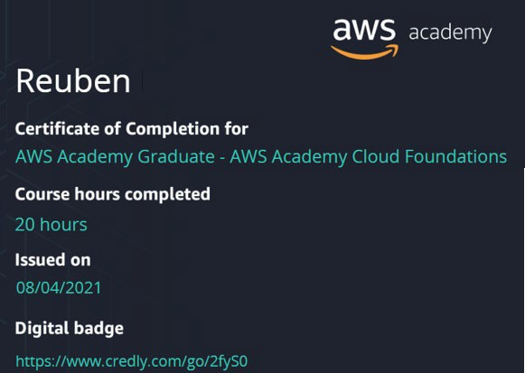
  - Screen shot of individual completion of subject survey
  - Group MAPS (Message, Audience, Purpose, Strategy) oral presentation framework.
    - The presentation should be cohesive, and each member will need to present. The group will present the Case Study Report to the Senior Investigation Officer (class tutor) using the MAPS (Message, Audience, Purpose, Strategy) oral presentation framework.
MAPS reference MAPS video
    - Fill up the following MAPS table and put into the group report Appendix.

Message | - What is the key/main idea/central idea?  - Is it supported with facts, evidence, data and figures?
Audience | - Who is/are my audience(s)?  - What is their background (e.g. age)?  - How much do they know about the topic?  - What is their attitude toward the topic?  - What would the audience need to know?
Purpose | - Is it to educate/share an idea?  - Is it to inform?  - Is it to persuade?  - Is it to express an idea/opinion/feeling?
Strategy | - What visual aids should I use to convey my message and achieve the purpose of my oral presentation?  - Are answers for anticipated questions from listeners prepared before the oral presentation?
END

